**EXPERIMENT 16 - Case Study of MYCIN and AI Shell**

**Aim:**

Case study of standard AI programs like MYCIN and AI Shell.

**Theoretical Background:**

MYCIN

MYCIN, an early expert system, or artificial intelligence (AI) program, for treating blood infections. In 1972 work began on MYCIN at Stanford University in California. MYCIN would attempt to diagnose patients based on reported symptoms and medical test results. The program could request further information concerning the patient, as well as suggest additional laboratory tests, to arrive at a probable diagnosis, after which it would recommend a course of treatment. If requested, MYCIN would explain the reasoning that led to its diagnosis and recommendation. Using about 500 production rules, MYCIN operated at roughly the same level of competence as human specialists in blood infections and rather better than general practitioners.

MYCIN Expert System History

Edward Shortliffe, the developer, was with the Department of Medicine and Computer Science at Stanford University School of Medicine. During its usage, this expert system provided recommendations about antibiotics to use for patients with meningitis. Advantages of this system included a high degree of accuracy; however, disadvantages included not exceeding human competency levels to that high a degree.

How MYCIN Expert System Works

MYCIN was an expert system using backward chaining, a form of artificial intelligence. In this context, backward chaining helped determine that the patient had an infection and worked back through several steps to determine the type of bacteria and which antibiotics to use. Advantages included making it easier to find out the causes because of the known endpoint.

MYCIN Expert System: Historical Significance

Experts describe MYCIN Expert System as having laid the foundations for all similar systems, making the design stand out in computer history. Although disadvantages included having an acceptable, rather than a high level of accuracy, this tool helped pave the way for further advancement in artificial intelligence. The system saw a lot of testing but never saw use in a clinical setting.

Researchers have learned from the advantages and disadvantages of this system to use its foundation in other applications. Examples of expert systems that have used similar technology include PXDES and CaDet, which medical professionals use to predict and identify cancer.

The MYCIN system comprises three major subprograms, as depicted in Figure above.

* The Consultation Program
* Explanation Program
* Knowledge Acquisition Program

The Consultation Program is the core of the system; it interacts with the physician to obtain information about the patient, generating diagnoses and therapy recommendations.

The Explanation Program provides explanations and justifications for the program’s actions.

The Knowledge-Acquisition Program is used by experts to update the system’s knowledge base.

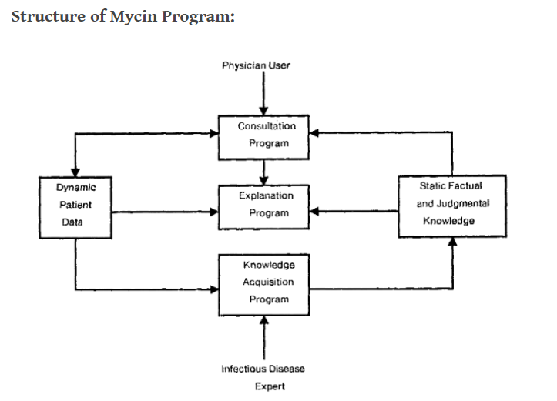

MYCIN was advanced for its time and had a competence level comparable to blood infection specialists and greater accuracy than general practitioners. The thought processes that it used were similar to human thought.

Researchers wrote this system in Lisp, a set of multiple programming languages designed to work with artificial intelligence. This system was the first system of its kind invented for medical usage.

MYCIN’s foundations came from another framework developed at Stanford called DENDRAL. This system helped find new chemical compounds in the organic chemistry field.

Research conducted at the Stanford Medical School found MYCIN to propose an acceptable therapy in about 69% of cases, which was better than the performance of infectious disease experts who were judged using the same criteria. This study is often cited as showing the potential for disagreement about therapeutic decisions, even among experts, when there is no “gold standard” for correct treatment.

AI Shell

AI Shell, also known as Artificial Intelligence Shell, is a computer program that provides an interface for AI applications and services. The program uses machine learning algorithms to process and analyze data and perform tasks based on the user's commands. AI Shell is a type of standard AI program that provides an interface for users to interact with AI systems and services in a simple and intuitive manner.

Some of the features of AI Shell include:

* Natural language processing (NLP) - enables the program to understand and respond to human language in a conversational manner.
* Knowledge representation - AI Shell uses a knowledge representation system to store and organize information for processing and retrieval.
* Machine learning algorithms - AI Shell uses machine learning algorithms to process and analyze data and make decisions based on the information provided.
* Intelligent agents - AI Shell employs intelligent agents that can perform tasks on behalf of the user, such as search and retrieval of information.

Overall, AI Shell is an example of a standard AI program that provides an interface for users to interact with AI systems and services in a simple and intuitive manner. The program can be used to perform a variety of tasks, including data analysis, decision-making, and information retrieval.

Applications or functions:

* Automation: AI shell programs can automate repetitive tasks, freeing up time and resources for other tasks.
* Decision Making: AI shell programs can make informed decisions based on data and algorithms, helping organizations to make better decisions.
* Predictive Analysis: AI shell programs can analyze large amounts of data and make predictions based on patterns, helping organizations make informed decisions.
* Natural Language Processing: AI shell programs can understand and process natural language, allowing for easy communication with humans.
* Personalization: AI shell programs can provide personalized experiences for users, tailoring recommendations and content based on their preferences and behaviors.
* Chatbots: AI shell programs can provide chatbot services for customer support, helping organizations to improve their customer service and reduce costs.
* Data Analysis: AI shell programs can analyze large amounts of data to uncover insights and trends, helping organizations to make informed decisions.
* Fraud Detection: AI shell programs can detect fraudulent activities, helping organizations to protect their assets and improve security.
* Optimization: AI shell programs can optimize processes, helping organizations to improve efficiency and productivity.
* Machine Learning: AI shell programs can use machine learning algorithms to improve their performance over time, becoming more effective and efficient with each iteration.

Historical background:

The history of artificial intelligence shell programs dates back to the early days of computing, when computer scientists first started exploring the potential of computers to perform tasks that were previously thought to be beyond their capabilities. In the 1950s, computer scientist John McCarthy first proposed the concept of artificial intelligence and began exploring ways to develop programs that could mimic human intelligence.

Over the following decades, AI research continued to grow and evolve, leading to the development of early AI shell programs that could perform basic tasks such as data analysis, decision making, and natural language processing. As computing power continued to increase, AI shell programs became more sophisticated and capable of performing a wider range of tasks.

In the 1980s, the development of expert systems marked a major milestone in the history of AI shell programs, as these systems were able to automate decision making and provide expert-level advice to users. In the 1990s, the development of machine learning algorithms allowed AI shell programs to improve their performance over time, becoming more effective and efficient.

Today, AI shell programs continue to play a major role in a wide range of industries, from finance and healthcare to retail and transportation. These programs have the potential to revolutionize the way we live and work, and are likely to play an increasingly important role in shaping our future.

**Conclusion:**

Case study of AI programs like MYCIN and AI Shell is done successfully.